**Coding Academy by Orange**

Summer 2022

Design and Implementation of E-Commerce Site for Online Shopping

NAHAND Project

*Coding Academy by Orange*

### Graduate Project

**Design and Implementation of**

**E-Commerce Site for Online Shopping**

***By***

## Nada Alawneh

Coding Academy by Orange

2022

# ABSTRACT

In today’s fast-changing business environment, it’s extremely important to be able to respond to client needs in the most effective and timely manner. If your customers wish to see your business online and have instant access to your products or services.

Online Shopping is a lifestyle e-commerce web application, which retails various fashion and lifestyle products (Currently Handmade Products and crafts). This project allows viewing various products available enables registered users to place order by using Cash on Delivery (Pay Later) option. This project provides an easy access to Administrators and Managers to view orders placed using Pay Later .

In order to develop an e-commerce website, a number of Technologies must be studied and understood. These include multi-tiered architecture, server and client side scripting techniques, implementation technologies such as laravel, programming language (such as php) and relational databases. This is a project with the objective to develop a basic website where a consumer is provided with a shopping cart application and also to know about the technologies used to develop such an application.

This document will discuss each of the underlying technologies to create and implement an e- commerce website.

# ACKNOWLEDGEMENTS

In completing this graduate project, I have been fortunate to have help, support and encouragement from many people. I would like to acknowledge them for their cooperation.

First and foremost, deeply thankful to my trainers’ coaches Ala’a Qazaq and Hala Hamdan, for their wonderful guidance during this project work in field of Computer Science, at Orange Coding Academy. I am also thankful for their continuous feedback and encouragement throughout this project work. Their broad knowledge and hardworking attitude have left me with very deep impressions and they will greatly benefit me throughout my life.

I would like to thank my job coach Hala Obiedat, and the manager of the academy Mohammed Frehat for their support throughout this project work.

## TABLE OF CONTENTS

ABSTRACT 3

ACKNOWLDEGEMENT 4

LIST OF FIGURES 6

1.0 INTRDUCTION 7

* 1. OVERALL DESCSRIPTION 7
  2. DESCRIPTION 7
  3. USING THE CODE 8
  4. WEB PAGES DETAILS 8
  5. PROJECT DETAILS 8
  6. SYSTEM REQUREMENT 9
  7. USE-CASE DIAGRAM 9
  8. ONLINE SHOPPING APPLICATION ………………………………………………10

### HOME PAGE

* 1. **SHOP PAGE ( PRDUCTS)**

### ORDER US PAGE

* 1. **CONTACT US PAGE**

### ABOUT US PAGE

* 1. **TRACK FOR ADMIN PAGE**

### REGISTER PAGE

* 1. **LOGIN**

### ADMIN PAGE

* 1. **ORDER VIEW FOR USER**

### PAYPAL FOR PAYMENT

* 1. **SUCCESS PAGE**

### FAILED PAGE

* 1. **DATA MANAGEMENT 16**

### DATA DESCRIPTION

* 1. **DATA OBJECTS**

### DATA TABLE DIAGRAM

* 1. **RELATIONSHIPS**

### NON-FUNCTIONAL / OPERATIONAL REQUIREMENTS 19

* 1. **SECURITY**

### EFFICIENCY AND MAINTAINABLITY

**7.0 CONCLUSION 19**

**8.0 REFERENCE 21**

# List of Figures

### HOME PAGE 10

### CLOTHING PAGE (PRODUCTS) 10

### ORDER US PAGE 11

### CONTACT US PAGE 11

### ABOUT US PAGE 12

### TRACK FOR ADMIN PAGE 12

### REGISTER PAGE 13

### LOGIN 13

### ADMIN PAGE 14

### ORDER VIEW FOR USER 14

### PAYPAL FOR PAYMENT 15

### SUCCESS PAGE 15

### FAILED PAGE 16

## 1.0 INTRODUCTION:

E-commerce is fast gaining ground as an accepted and used business paradigm. More and more business houses are implementing web sites providing functionality for performing commercial transactions over the web. It is reasonable to say that the process of shopping on the web is becoming commonplace.

The objective of this project is to develop a general-purpose e-commerce store where product like handmade can be bought from the comfort of home through the Internet. However, for implementation purposes, this paper will deal with an online shopping for crafts.

An online store is a virtual store on the Internet where customers can browse the catalog and select products of interest. The selected items may be collected in a shopping cart. At checkout time, the items in the shopping cart will be presented as an order. At that time, more information will be needed to complete the transaction. Usually, the customer will be asked to fill or select a billing address, a shipping address, a shipping option. A message will appear to the customer as soon as the order is placed.

## OVERALL DESCRIPTION:

### Description:

* + - Any member can register and view available products.
    - Only registered member can purchase multiple products regardless of quantity.
    - Contact Us page is available to contact Admin for queries.
    - There are three roles available: Visitor, User and Admin.
      * Visitor can view available products.
      * User can view and purchase products.

• An Admin has some extra privilege including all privilege of visitor and user.

Admin can add categories, edit category information and add/remove category.

Admin can add products, edit product information and add/remove product.

Admin can add user, edit user information and can remove user.

### Using the code:

1. Attach the database in your "MYSQL Server Management Studio Express".
2. Run the application on Microsoft Visual Studio as web site.
3. Locate the database.

### Web Pages details:

* + - Home Page
    - About Us Page
    - Shop Page
    - Single Product Page
    - Contact Us Page
    - Admin Page
    - Login Page
    - Register Page
    - Cart page
    - Checkout Page
  1. **Project Detail:**

**Online shopping 3-tier architecture**

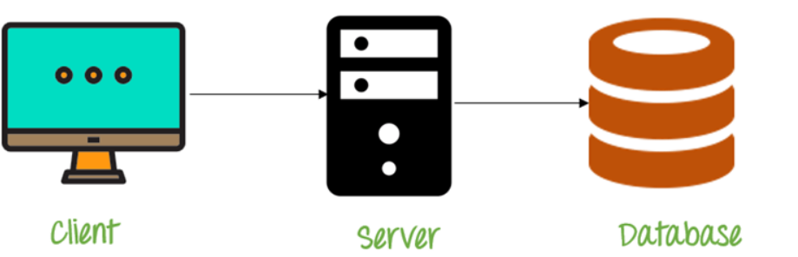

Apache, Laravel

Web Browser

MYSQL RDBMS

## SYSTEM REQUREMENTS:

### USE-CASE DIAGRAM:

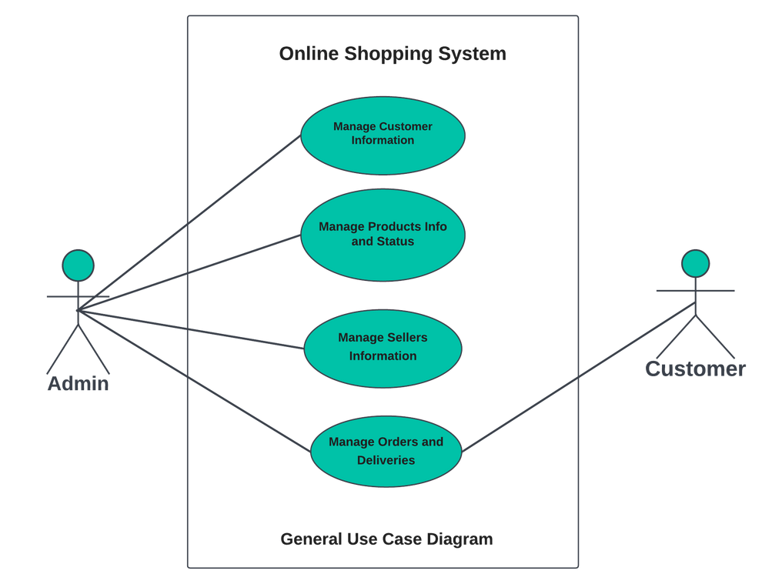

## ONLINE SHOPPING APPLICATION:

Anyone can view Online Shopping portal and available products, but every user must login by his/her Username and password in order to purchase or order products. Unregistered members can register by navigating to registration page. Only Admin will have access to modify roles, by default developer can only be an ‘Admin’. Once user register site, his default role will be ‘User’.

* 1. **HOMEPAGE:** The Home Screen will consist of screen were one can browse through the products which we have on our website



**Figure1: Home Page**

**4.2. CLOTHING PAGE (PRODUCTS):** This page consists of product details. This page appears same for both visitors and users.

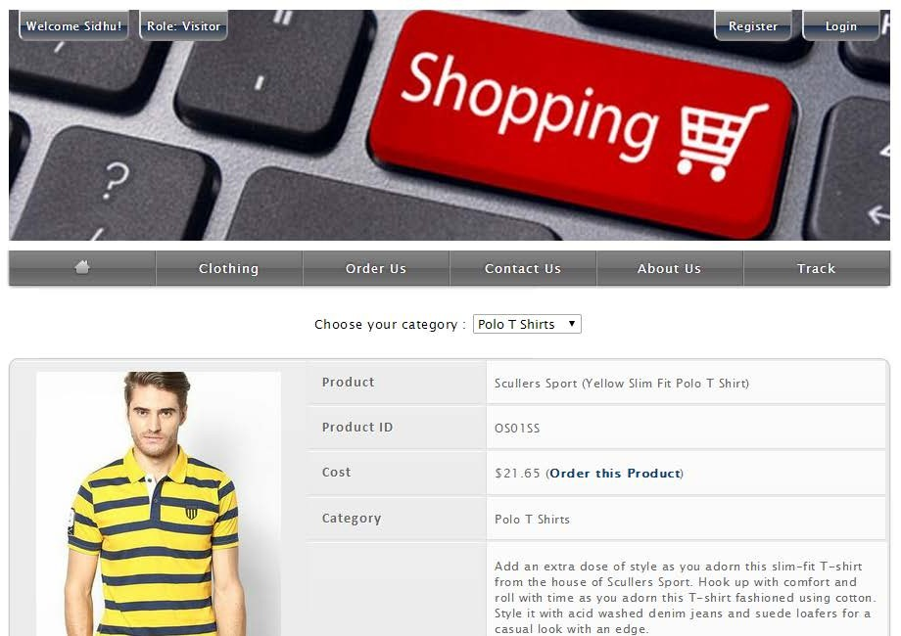

Figure 2: Clothing Page

* 1. **Order Us Page:** Registered users can order desired products from here.

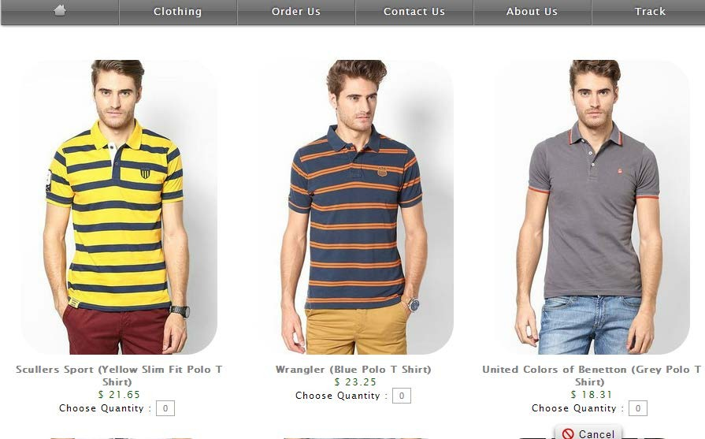

Figure 3: Order Us Page

* 1. **Contact Us Page:** Visitors and Registered users can contact website owners or administrators from here

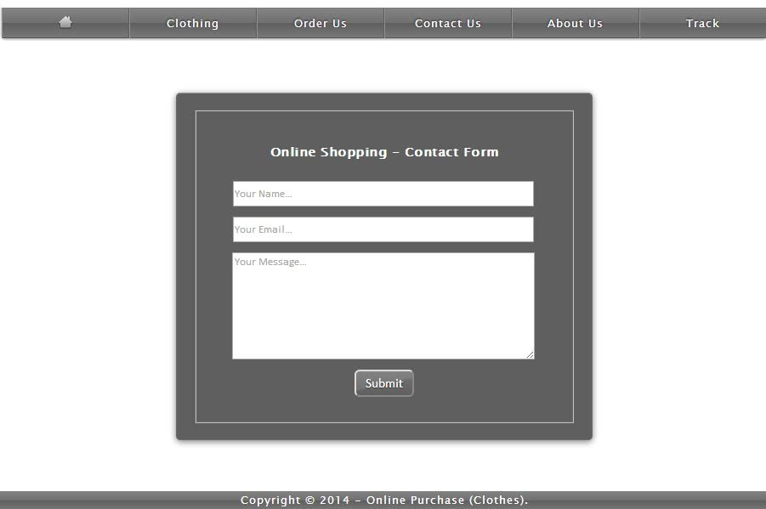

Figure 4: Contact Us Page

* 1. 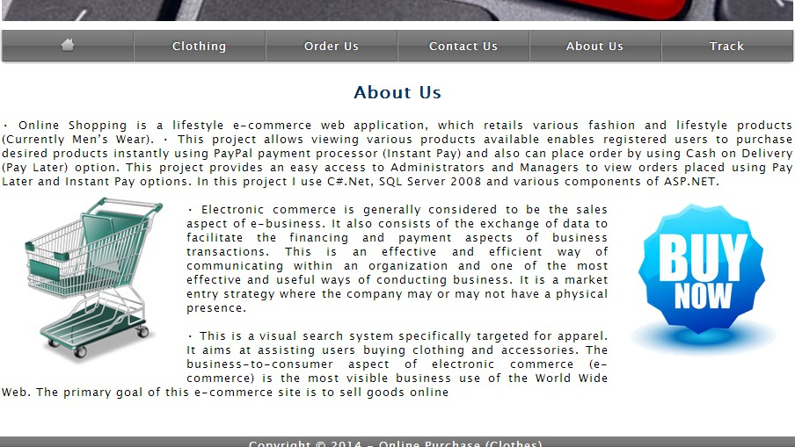**ABOUT US PAGE:** This page describes about website and owners

Figure 5: About us Page

* 1. **Track For Admin Page:** Website Administrators can track and ship orders here.

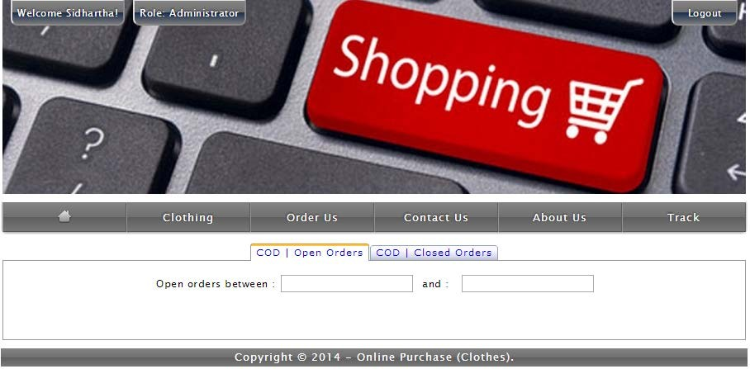

Figure 6: Tracking Page for Admin.

* 1. **REGISTER PAGE:** New users can register here

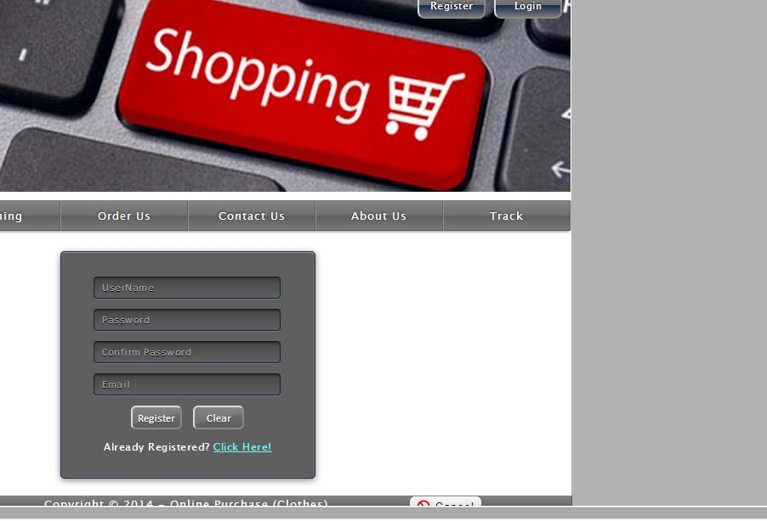

Figure 7: Register Page

* 1. **LOGIN PAGE:** Login page for both users and administrators.

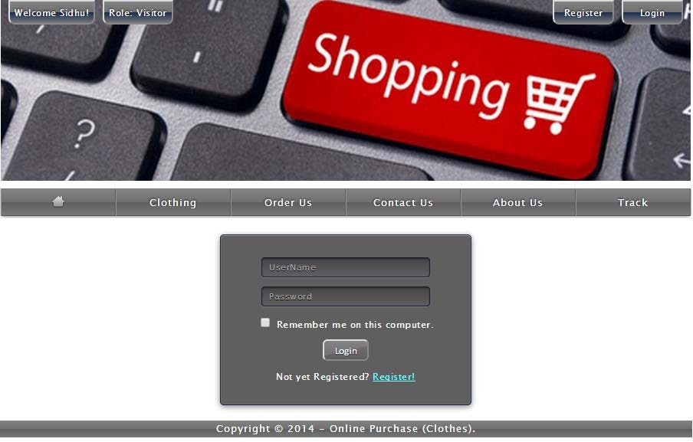

* 1. **Admin Page:** Only difference you see in this page is Role: Admin. User and Admin role will be checked once the page was login and Session [“role”] will be either Admin or User. If credentials belong to Admin then role will be Admin and if credentials belong to User then role will be User.



Figure 9: Admin Page

* 1. **ORDER VIEW FOR USER:** Once users order item they are able to see ordered products and grand total.

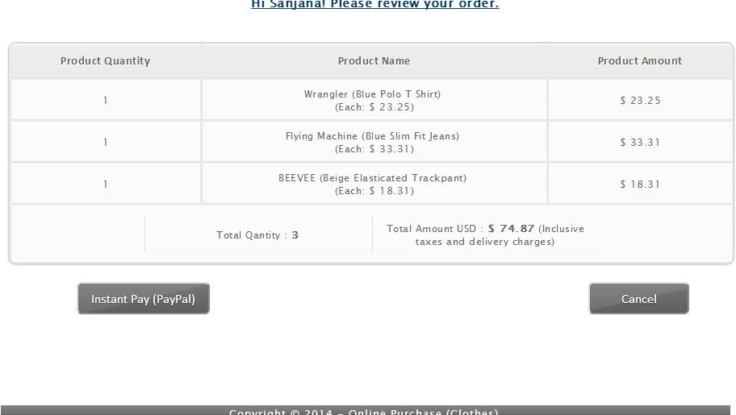

Figure 10: Order View for User

* 1. **PAYPAL FOR PAYMENT:** Once users orders products they are redirected to payment page.

L 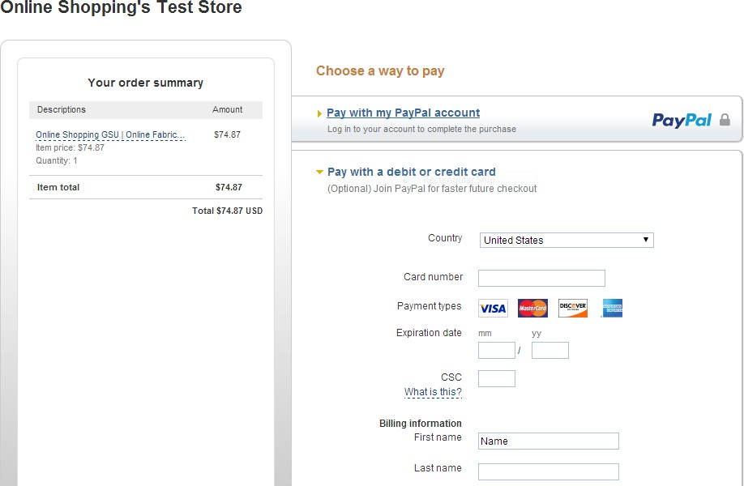

Figure 11: PayPal Page

### Figure 4.12: Success URL

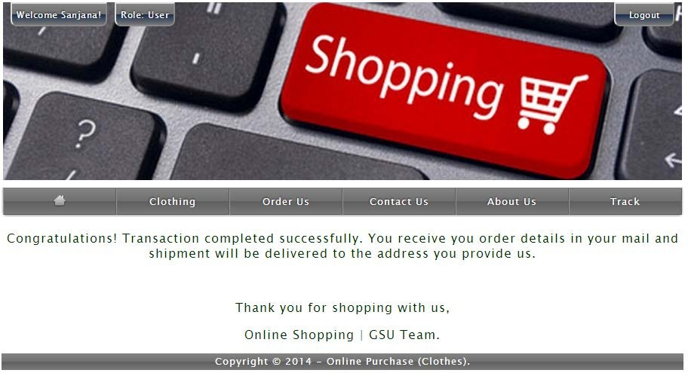

**Figure 12: Success URL FIGURE 4.12:** Failed URL

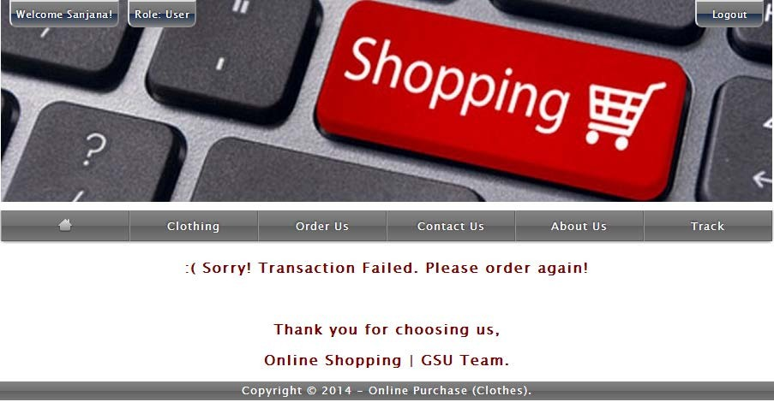

**Figure 12: Failed URL**

## Data Management

### Data Description

This database consists of

* + - Users: User and Admin information is added to database with Unique ID based on their roles.
    - Shopping: Complete products information is stored in this table.
    - Orders: Customer ordered products, status and delivery information is stored in this table.
  1. **Data Objects**
     + User: ID, UserName, Password, Email, Role
     + Shopping: ID, Product, Product ID, Cost, Category, Image, Description
     + Orders: ID, Client, Product, Quantity, Price, Date, OrderShipped
  2. **Database Table Diagram**

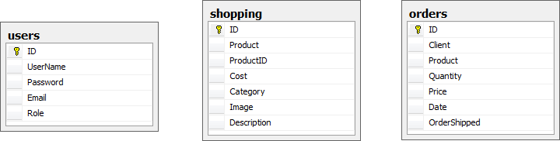

* 1. **Relationships:**

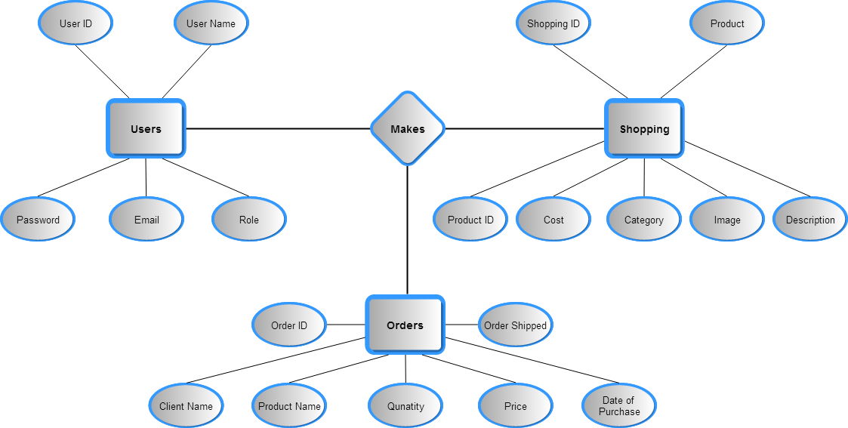

## Non-Functional / Operational Requirements

### Security

* + - Pages of the website must be access in the way they were intended to be accessed.

Included files shall not be accessed outside of their parent file.

* + - Administrator can only perform administrative task on pages they are privileged to access. Customers will not be allowed to access the administrator pages.

### Efficiency and Maintainability

* + - Page loads should be returned and formatted in a timely fashion depending on the request being made.
    - Administrators will have the ability to edit the aspects of the order forms, product descriptions, prices and website directly

## 7.0 Conclusion:

The Internet has become a major resource in modern business, thus electronic shopping has gained significance not only from the entrepreneur’s but also from the customer’s point of view. For the entrepreneur, electronic shopping generates new business opportunities and for the customer, it makes comparative shopping possible.

As per a survey, most consumers of online stores are impulsive and usually make a decision to stay on a site within the first few seconds. “Website design is like a shop interior. If the shop looks poor or like hundreds of other shops the customer is most likely to skip to the other site. Hence we have designed the project to provide the user with easy navigation, retrieval of data and necessary feedback as much as possible. In this project, the user is provided with an e- commerce web site that can be used to buy books online. To implement this as a web application we used ASP.NET as the Technology. ASP.NET has several advantages such as enhanced performance, scalability, built-in security and simplicity.

To build any web application using ASP.NET we need a programming language such as C#, VB.NET, J# and so on. C# was the language used to build this application. For the client browser to connect to the ASP.NET engine we used Microsoft’s Internet Information Services (IIS) as the Web Server. ASP.NET uses ADO.NET to interact with the database as it provides in-memory caching that eliminates the need to contact the database server frequently and it can easily deploy and maintain an ASP.NET application. SQL was used as back-end database since it is one of the most popular databases, and it provides fast data access, easy installation and simplicity.

A good shopping cart design must be accompanied with user-friendly shopping cart application logic. It should be convenient for the customer to view the contents of their cart and to be able to remove or add items to their cart. The shopping cart application described in this project provides a number of features that are designed to make the customer more comfortable.

This project helps in understanding the creation of an interactive web page and the technologies used to implement it. The design of the project which includes Data Model and Process Model illustrates how the database is built with different tables, how the data is accessed and processed from the tables. The building of the project has given me a precise knowledge about how ASP.NET is used to develop a website, how it connects to the database to access the data and how the data and web pages are modified to provide the user with a shopping cart application.

## References:

* + 1. Anne Boehm, Joel Murach, Murach’s ASP.NET 4 Web Programming with C# 2010, 4th Edition, Murach, 2010.
    2. Bryan Syverson, Joel Murach, Murach’s SQL Server 2012 for developers, Murach, 2012.
    3. <http://www.w3schools.com/>
    4. <http://msdn.microsoft.com/>
    5. <http://agilemodeling.com/>
    6. <http://csharp-video-tutorials.blogspot.co.uk/p/free-dot-net-video-tutorials-for.html>
    7. <http://csharp-video-tutorials.blogspot.com/p/free-aspnet-video-tutorial.html>
    8. <http://csharp-video-tutorials.blogspot.com/p/free-adonet-video-tutorial.html>